Exposure Java for APCS | FRQuiz14.01 | Date:
Name: KEY |  | Period:

This quiz involves knowledge of the program code from the Train Case Study that has been used to explain polymorphism in Chapter 14. Consider the RailCar class on this page. The class is incomplete and strictly concentrates on those methods necessary to draw the RailCar object, which are the only methods of concern for this quiz.

public class RailCar
{
public void drawCar(Graphics g)
{
drawContainer(g);
drawRailWheels(g);
drawLink(g);
}
private void drawContainer(Graphics g)
{
g.setColor(carColor);
g.fillRect(carX,carY,150,100);
}
private void drawRailWheels(Graphics g)
{
g.setColor(Color.black);
g.fillOval(carX+5,carY+75,50,50);
g.fillOval(carX+95,carY+75,50,50);
}
private void drawLink(Graphics g)
{
g.setColor(Color.black);
g.fillRect(carX-25,carY+80,25,5);
}
}

Also consider the incomplete PassengerCar class. The attributes and many methods are not present. Again the concentration is on the drawing of the PassengerCar object. Note that the drawCar method is incomplete.

public class PassengerCar extends RailCar
{
public void drawCar(Graphics g)
{
/* To be completed for this quiz */
}
private void drawWindows(Graphics g)
{
g.setColor(Color.white);
g.fillRect(carX+10,carY+30,25,30);
g.fillRect(carX+45,carY+30,25,30);
g.fillRect(carX+80,carY+30,25,30);
g.fillRect(carX+115,carY+30,25,30);
}
private void drawRoof(Graphics g)
{
Polygon roof = new Polygon();
roof.addPoint(carX-15,carY+20);
roof.addPoint(carX,carY);
roof.addPoint(carX+150,carY);
roof.addPoint(carX+165,carY+20);
g.setColor(carColor);
g.fillPolygon(roof);
}
}

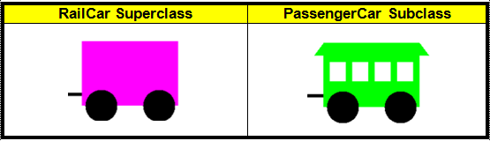

Complete method drawCar of the PassengerClass below. The pictures shown above show the image of a RailCar object and the image of a PassengerCar object. You are not concerned with the location of the objects, nor the color of the objects, which are provided when a new object is instantiated.

public void drawCar(Graphics g)
{
super.drawCar(g);
drawWindows(g);
drawRoof(g);
}

